Donating to the UUCG Auction is as easy as A, B, C
Agree to be an auction sponsor –Silver, Gold, Diamond, or Platinum
Bake a cake
Crochet an afghan
Deliver a home-cooked meal to the highest bidder
Entertain a child while parents have an afternoon out
Figure out a tax return
Groom a dog
Help organize an office
Install a flower bed
Just plan your favorite meal and put it up for bid – your house or theirs
Kvetch over coffee with friends, old andnew
Loan the use of your pickup truck
Make décor for a child’s room
Nail down loose boards or clean out a gutter
Open your home for drinks and games
Play music a winning bidder’s party
Quilt a wall hanging
Repair an appliance
Speak a foreign language? Understand math? Offer tutoring sessions
Teach an ethnic cooking class
Undo a computer glitch
Virtually any service or social event will bring big bucks for UUCG
Watch a cult movie in costume with a gang of high bidders
X-spect to have great fun at the Auction
Yipee! The Auction is almost here!
Zip on over to the Auction on April 25th.

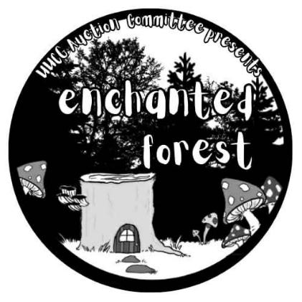
2026 UUCG Auction Donation Form

The annual auction, from 5:00-9:00 pm on April 25th, is UUCG’s largest fundraising event of the year. Everyone has something to offer! Contribute events, services, parties, adventures, and unique items to help make the auction a success.
Contact Person: _________________________________________________________________________
Address: _______________________________________________________________________________
Phone: ____________________________________ Email: _________________________________

(PLEASE USE A SEPARATE FORM FOR EACH DONATED ITEM)
[ ] Tangible Item
[ ] Event (Party / Service / Lessons / Entertainment)
Name of Item or Event: ____________________________________________________________________
Fair Market Value: $__________________ Expiration Date: _________________
Description: ____________________________________________________________________________________
________________________________________________________________________________________________________________________________________________________________________
If your donation is an event, do you know the date? ___ yes ___no
Date: __________ Time: __________ Total number of tickets or guests: __________
Location: _________________________________________________________________________
The Auction Item Committee will review all donated items to ensure the auction has a wide assortment of quality items, services, and events that are popular with bidders. All donations are tax deductible. Please return paper forms to the bird cage at the auction display or to the Secretary’s mailbox in the office.

Donation information must be submitted by April 4 for inclusion in the Auction Catalog and to be entered into a drawing for a magical prize. All donated items should be delivered to UUCG on Sunday, April 19th or Friday, April 24th. Questions? Contact Auction@UUCG.org

SPONSORSHIP INFORMATION FOR
ENCHANTED FOREST UUCG ANNUAL AUCTION
Would you like to contribute toward the Unitarian Universalist Congregation of Gwinnett’s largest fundraiser of the year and get your name in front of a community of awesome, fun, creative folkx, who would love to investigate your business?

This year’s Enchanted Forest auction will distribute a booklet of items for bid to approximately 80-100 pairs of eyes. All businesses and congregation members will receive a listing with their donation information.

For more support and more exposure, you can purchase an ad in this booklet for the following price:
¼ page ad: 2¾ x 4¼ inches: $75
½ page ad: 5½ x 4¼ inches: $150
Full page ad: 5½ x 8½ inches: $250
This ad may talk up your business, offer a coupon, or simply be a message of love for the congregation.

Yes! I would like to purchase an ad of the following size:
¼ page; Name: ________________________________________________________

½ page; Name: ________________________________________________________

Full page; Name: ________________________________________________________

Please briefly describe what you want your ad to look like. ______________________________

__________________________________________________________________________________

Your phone and email address. We will be in touch. ______________________________

